1. How to find the length of string using while loop.

<https://www.geeksforgeeks.org/python-string-length-len/?ref=lbp>

<https://codescracker.com/python/program/python-program-find-length-of-string.htm>

<https://stackoverflow.com/questions/28166011/python-while-loop-with-string>

1. Search for Time and Space complexity

<https://www.geeksforgeeks.org/time-complexity-and-space-complexity/>

<https://blog.devgenius.io/python-time-complexities-1988ec5d16d9>

## ****Types of Mean****

There are majorly 3 distinct types of mean value that you will find in statistics.

* [Arithmetic Mean](https://testbook.com/maths/arithmetic-mean)
* [Geometric Mean](https://testbook.com/maths/geometric-mean)
* [Harmonic Mean](https://testbook.com/maths/harmonic-mean)

### ****Arithmetic Mean****

The **Arithmetic Mean** is the average of the numbers/data or can be understood as the calculated central value of a set of numbers. To determine Arithmetic Mean:

* Add all the numbers/data given.
* Divide the total obtained in the above steps by the total numbers/data.

X=∑ni=1XiN𝑋=∑𝑖=1𝑛𝑋𝑖𝑁

Here N= Total number of observations.

Learn about [Assumed Mean Method](https://testbook.com/maths/assumed-mean-method)

### ****Geometric Mean****

The **Geometric Mean**or**GM** is the average value or mean which implies the central tendency of the set of numbers by using the root of the product of the values. Below is the formula for the Geometric Mean calculation.

Consider, if x1,x2…. xn are the observation, then the G.M is defined as𝐶𝑜𝑛𝑠𝑖𝑑𝑒𝑟, 𝑖𝑓 𝑥1,𝑥2…. 𝑥𝑛 𝑎𝑟𝑒 𝑡ℎ𝑒 𝑜𝑏𝑠𝑒𝑟𝑣𝑎𝑡𝑖𝑜𝑛, 𝑡ℎ𝑒𝑛 𝑡ℎ𝑒 𝐺.𝑀 𝑖𝑠 𝑑𝑒𝑓𝑖𝑛𝑒𝑑 𝑎𝑠

GM=x1×x2×x3…..xn−−−−−−−−−−−−−−−−−√n𝐺𝑀=𝑥1×𝑥2×𝑥3…..𝑥𝑛𝑛

GM=(x1×x2×x3…..xn)1n𝐺𝑀=(𝑥1×𝑥2×𝑥3…..𝑥𝑛)1𝑛

This can also be written as;

logG.M=∑log xinlog⁡𝐺.𝑀=∑log⁡ 𝑥𝑖𝑛

GM=Antilog ∑log xin𝐺𝑀=𝐴𝑛𝑡𝑖log⁡ ∑log⁡ 𝑥𝑖𝑛

G.M.=∏ni=1xi−−−−−−√n𝐺.𝑀.=∏𝑖=1𝑛𝑥𝑖𝑛

For any Grouped Data, G.M can be written as:GM=Antilog ∑f.log xin𝐹𝑜𝑟 𝑎𝑛𝑦 𝐺𝑟𝑜𝑢𝑝𝑒𝑑 𝐷𝑎𝑡𝑎, 𝐺.𝑀 𝑐𝑎𝑛 𝑏𝑒 𝑤𝑟𝑖𝑡𝑡𝑒𝑛 𝑎𝑠:𝐺𝑀=𝐴𝑛𝑡𝑖log⁡ ∑𝑓.log⁡ 𝑥𝑖𝑛

Thus, the geometric mean is also represented as the nth root of the product of n numbers. values.

### ****Harmonic Mean****

Harmonic Mean or HM is determined as the reciprocal of the average of the reciprocals of the data values. The harmonic mean formula is applied to calculate the average of a set of numbers.

Ifx1, x2 , x3,…, xn are the individual items then;𝐼𝑓𝑥1, 𝑥2 , 𝑥3,…, 𝑥𝑛 𝑎𝑟𝑒 𝑡ℎ𝑒 𝑖𝑛𝑑𝑖𝑣𝑖𝑑𝑢𝑎𝑙 𝑖𝑡𝑒𝑚𝑠 𝑡ℎ𝑒𝑛;

H.M=n1x1+1x2+1x3+⋯+1xn=n∑ni=11xi𝐻.𝑀=𝑛1𝑥1+1𝑥2+1𝑥3+⋯+1𝑥𝑛=𝑛∑𝑖=1𝑛1𝑥𝑖

For a frequency distribution, the harmonic mean formula is:𝐹𝑜𝑟 𝑎 𝑓𝑟𝑒𝑞𝑢𝑒𝑛𝑐𝑦 𝑑𝑖𝑠𝑡𝑟𝑖𝑏𝑢𝑡𝑖𝑜𝑛, 𝑡ℎ𝑒 ℎ𝑎𝑟𝑚𝑜𝑛𝑖𝑐 𝑚𝑒𝑎𝑛 𝑓𝑜𝑟𝑚𝑢𝑙𝑎 𝑖𝑠:

H.M=N∑ni=1f1xi𝐻.𝑀=𝑁∑𝑖=1𝑛𝑓1𝑥𝑖

Here N=summation of f.

In general, the harmonic mean is used when there is a requirement to give higher weight to the smaller items. It is used in the case of times and average rates.

### ****Important Points on Mean****

* The mean is the arithmetical average of a set of two or more numbers.
* Arithmetic mean geometric mean and harmonic mean are three types of mean that can be calculated.
* Summing the numbers/data in a set and dividing it by the total number provides the arithmetic mean.
* The geometric mean is somewhat complicated and includes the multiplication of the numbers using the nth root.
* The mean serves to evaluate the performance of an investment or company over a while, and several other uses.
* Average is different from an Arithmetic Mean.

We hope that the above article on Mean is helpful for your understanding and exam preparations. Stay tuned to the [Testbook app](https://link.testbook.com/5BfIEjq6Vyb) for more updates on related topics from Mathematics, and various such subjects. Also, reach out to the test series available to examine your knowledge regarding several exams

## What is a normal distribution?

The normal distribution is a theoretical distribution of values for a population. Often referred to as a bell curve when plotted on a graph, data with a normal distribution tends to accumulate around a central value; the frequency of values above and below the center decline symmetrically.

## How is the normal distribution used?

Many statistical analysis methods assume the data are from a normal distribution. If it isn't, the analysis might not be correct.

## Can I check if my data is 'normal'?

Yes. You can do simple visual checks. Most statistical software will do a formal statistical test.

## Defining the normal distribution

### See how to assess normality using [statistical software](https://www.jmp.com/en_us/home.html)

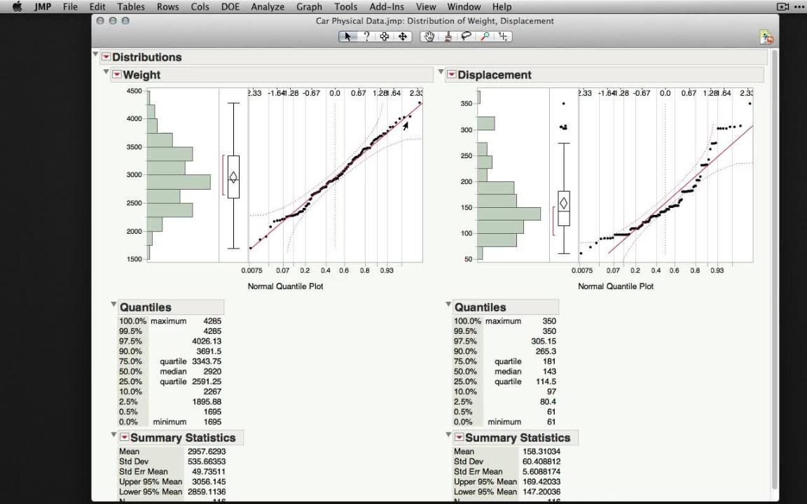

Play Video

* [Download JMP](https://www.jmp.com/en_us/download-jmp-free-trial.html) to follow along using the sample data included with the software.
* To see more JMP tutorials, visit the [JMP Learning Library](https://www.jmp.com/en_us/learning-library.html).

The normal distribution is a theoretical distribution of values for a population and has a precise mathematical definition. Data values that are a sample from a normal distribution are said to be “normally distributed.” Instead of diving into complex math, let’s look at the useful properties of the normal distribution and why it is important in analyses.

First, why do we care about the normal distribution?

* Many measurements are normally distributed, or nearly so. Examples are height, weight and heart rate. Notice that all of these are measured on a scale with many possible values.
* Many averages of measurements are normally distributed, or nearly so. For example, your daily commute time might not be normally distributed. But the monthly **average** of your daily commute time is likely to be normally distributed.
* Many statistical methods depend on the data being normally distributed. In this case, you will read that the method “assumes data is normally distributed” or “assumes normality.”

One of your first actions for a set of data values should be to look at the shape of the data. The normal distribution has a symmetrical shape. It is sometimes called a bell curve because a plot of the distribution looks like a bell sitting on the ground.

Figure 1 below shows a [histogram](https://www.jmp.com/en_us/statistics-knowledge-portal/exploratory-data-analysis/histogram.html) for a set of sample data values along with a theoretical normal distribution (the curved blue line). The histogram is a type of bar chart that shows the frequency of data values. You can see that the data do not match up exactly with the curve, which is common. In fact, if you see data that exactly matches a theoretical normal distribution, you will want to ask a lot of questions. Real-life data rarely matches a distribution exactly.

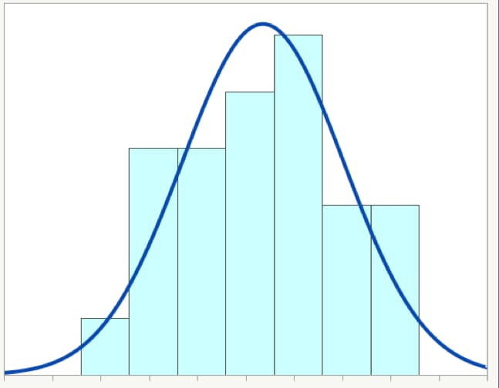

*Figure 1: Histogram of data that is approximately normally distributed*

## Summary of features

The normal distribution has the following features:

1. It is completely defined by the mean and [standard deviation](https://www.jmp.com/en_us/statistics-knowledge-portal/measures-of-central-tendency-and-variability/standard-deviation.html).
2. The [mean, median and mode](https://www.jmp.com/en_us/statistics-knowledge-portal/measures-of-central-tendency-and-variability/mean-median-and-mode.html) are all identical.
3. It is symmetrical.
4. It is bell-shaped.

Each feature is significant and tells you something about your data. Let's take a closer look:

### 1. Completely defined by mean and standard deviation

We need only two values – the mean and the standard deviation – to draw a picture of a specific normal distribution. (To further explore the relationship between the mean and the standard deviation for normally distributed data, read about the [empirical rule](https://www.jmp.com/en_us/statistics-knowledge-portal/measures-of-central-tendency-and-variability/empirical-rule.html).)

The mean and standard deviation are referred to as the parameters of the normal distribution. All distributions have parameters, and some have more than two. In any situation, the parameters will define a specific distribution.

Let's look at some examples of normal distribution curves.

Figure 2 shows two normal distributions, each with the same mean of 30. The thinner, taller distribution shown in blue has a standard deviation of 5. The wider, shorter distribution shown in orange has a standard deviation of 10.

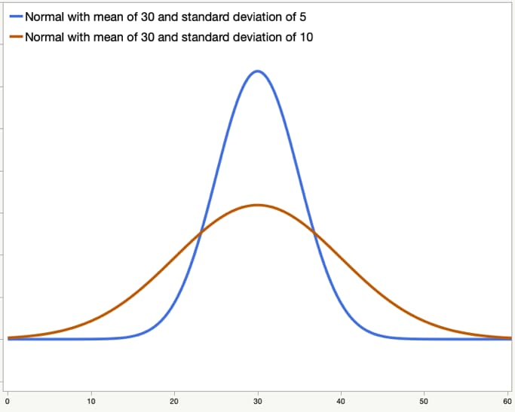

*Figure 2: Two normal distributions with the same mean and different standard deviations*

Figure 3 also shows two normal distributions, each with the same standard deviation of 5. The one on the left, shown in orange, has a mean of 20, while the one on the right, shown in blue, has a mean of 40.

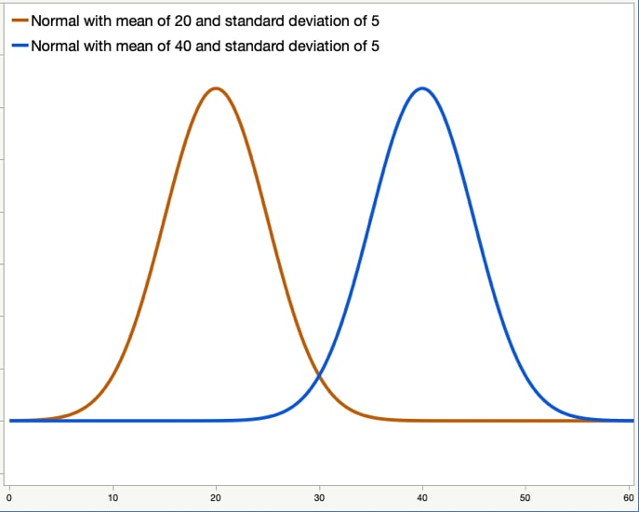

*Figure 3: Two normal distributions with different means and the same standard deviation*

Figure 4 again shows two normal distributions. The distribution shown in orange has a mean of 30 and a standard deviation of 10. The distribution in blue has a mean of 40 and a standard deviation of 5.

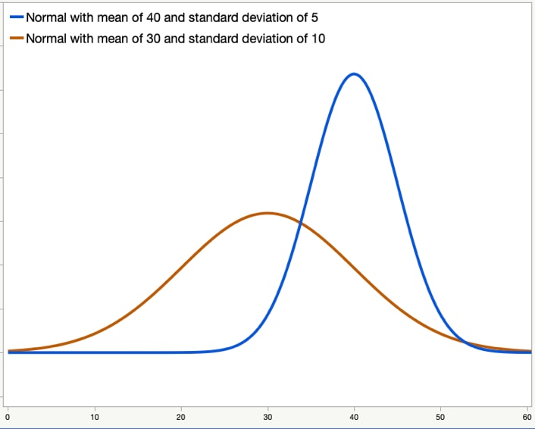

*Figure 4: Two normal distributions with different means and standard deviations*

### 2. Mean = median = mode

The mean, median and mode are three ways to measure the center of a set of data values. For a true normal distribution, these three are identical. In practice, your data is likely to be nearly normal. The mean, median and mode are likely to be very close to each other, but not identical.

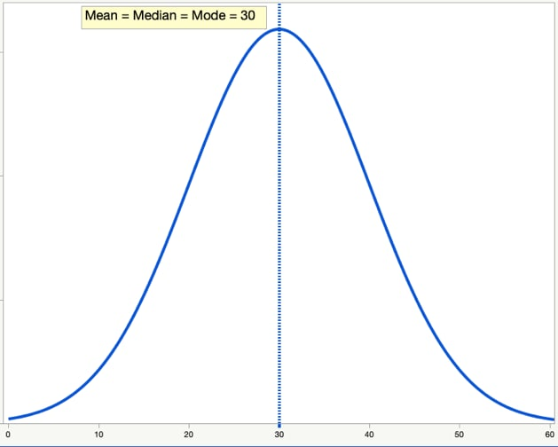

*Figure 5: True normal distribution in which mean, median, and mode are the same*

### 3. Symmetrical

The normal distribution is symmetrical. If you think about folding the graph in half at the mean, each side will be the same.

### 4. Bell-shaped

The normal distribution is bell-shaped with one central “hump,” which can be seen in the examples above.

Figure 6 shows a distribution that is non-normal. It has two humps instead of one. A distribution with two humps could indicate that there are different groups that are mixed up in the data. For example, heart rates are usually normally distributed. But suppose, unknown to you, the data has the resting heart rate for two groups: athletes and inactive people. You might get a bimodal distribution like the one below.

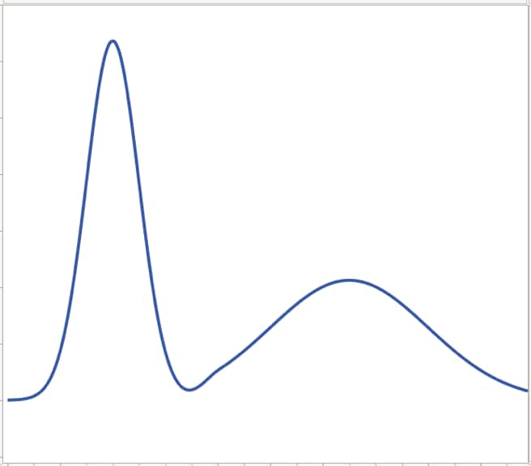

*Figure 6: Non-normal, bimodal distribution*

## If it’s not normal, is it abnormal?

If your data is not “normal,” does that mean that it is abnormal? No. Does it mean your data is bad? No. Different types of data will have different underlying distributions.

There are many possible theoretical distributions. Many statistical methods depend on the data coming from a normal distribution. When that isn't the case, there are other methods that you can use.

In practice, you will find that data is often “nearly normal.” There are some simple visual tools to check for normality, and most software packages have formal statistical tests for normality.

What are some examples of data that is not normally distributed?

* Individual throws of a six-sided die
* Coin flips
* Pass/fail checks in manufacturing
* Waiting time in a line
* Time to failure for batteries or other electronics
* File sizes of videos posted on the internet

Even though the examples are not normally distributed, there are analysis methods for these types of data.

## Visual tools to check for normality

### Using a histogram

As was mentioned above, a histogram is a special type of frequency bar chart for continuous variables. This chart can help you see if the data follows a general bell curve or not. With some software packages, you can also add a normal curve to your histogram as a visual comparison.

Figure 7 shows an example of a histogram for data that is not from a normal distribution.

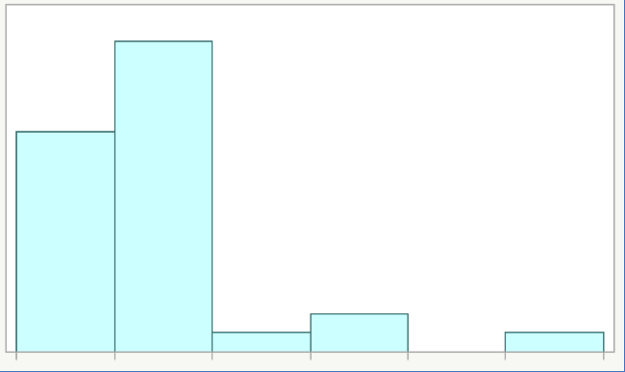

*Figure 7: Histogram for data that is non-normal*

When you look at a histogram as a visual check for normality, see if the chart:

* Has extreme values or not.
* Follows a symmetrical curve that is almost the same on both sides.
* Is bell-shaped or not.

As you can see, Figure 7 has extreme values, is not symmetrical and is not bell-shaped.

### Using a box plot

A [box plot](https://www.jmp.com/en_us/statistics-knowledge-portal/exploratory-data-analysis/box-plot.html) for a normal distribution shows that the mean is the same as the median. It also shows that the data has no extreme values. The data will be symmetrical.

Take a look at the two box plots in Figures 8 and 9 below. The data in Figure 8 is from a nearly normal distribution. The data in Figure 9 is from a non-normal distribution.

When you look at a box plot as a visual check for normality, see if the plot shows:

* Extreme values or not. The plot for the non-normal distribution in Figure 9 shows three outliers as red dots. The plot for the nearly normal distribution in Figure 8 shows no outliers.
* Symmetry or not. The plot for the nearly normal distribution (Figure 8) shows symmetry, while the plot for the non-normal distribution (Figure 9) does not.
* Mean and median nearly equal. In these box plots, the horizontal black center line in the box is the median, and the blue line is the mean. For the nearly normal distribution in Figure 8, the blue line for the mean is almost the same as the line in the middle of the box for the median.

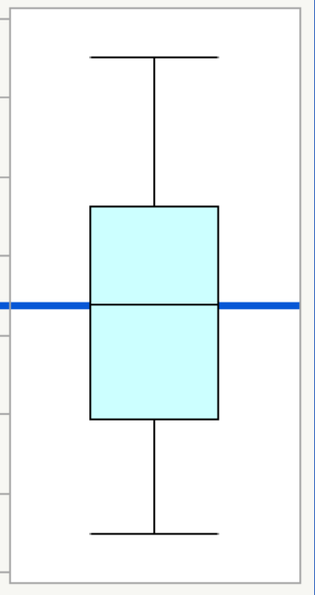

*Figure 8: Box plot for a nearly normal distribution*

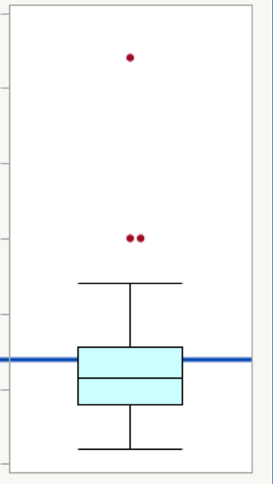

*Figure 9: Box plot for non-normal data*

### Using a normal quantile plot

A normal quantile plot shows a normal distribution as a straight line instead of as a bell curve. If your data are normal, then the data values will fall close to the straight line. If your data are non-normal, then the data values will fall away from the straight line. The pattern of the data on the plot can help you understand why your data are not normally distributed.

Figure 10 shows a normal quantile plot for data from a normal distribution. You can see how most of the data values fall near the solid red line. The data values also all fall within the dotted red confidence bounds.

Figure 11 shows data that is not from a normal distribution. Some of the data values are near the solid red line, but most of them are not. Some of the data values are outside of the dotted red confidence bounds. There are also some extreme values in the upper right.

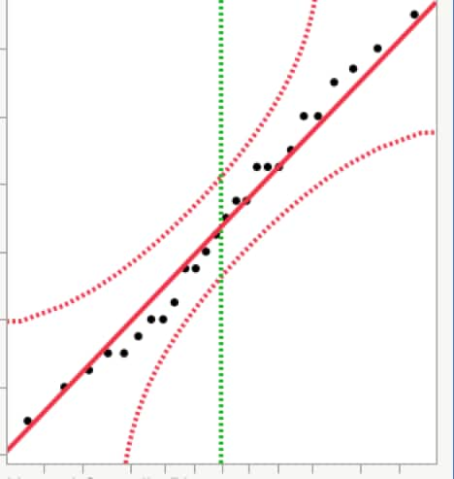

*Figure 10: Normal quantile plot for data that is normally distributed.*

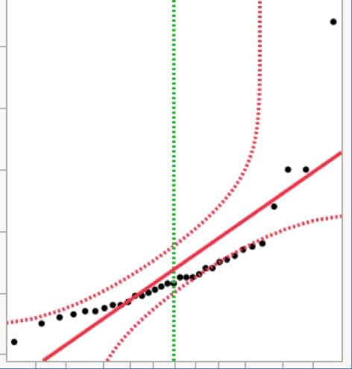

*Figure 11: Normal quantile plot for data that is not normally distributed.*

Most statistical software will create normal quantile plots. When you look at a normal quantile plot for normality, see if the data:

* Has extreme values or not.
* Follows mostly along the line that shows the normal distribution.
* Falls within the confidence bounds most of the time.

## When to use the normal distribution

### Continuous data: YES

The normal distribution makes sense for continuous data, since these data are measured on a scale with many possible values. Some examples of continuous data are:

* Age
* Blood pressure
* Weight
* Temperature
* Speed

For all of these examples, it makes sense to consider using methods that assume a normal distribution. However, remember that not all continuous data will follow a normal distribution. Plot your data, and think about what your data represents before you apply a method that assumes normality.

### Ordinal or nominal data: NO

The normal distribution does not make sense for raw ordinal or raw nominal data since these data are measured on a scale with only a few possible values.

With ordinal data, the sample is divided into groups, and the responses often have a specific order. For example, in a survey where you are asked to give your opinion on a scale from “Strongly Disagree” to “Strongly Agree,” your responses are ordinal.

For nominal data, the sample is also divided into groups but there is no particular order. Two examples are biological sex and country of residence. You can use M for male and F for female in your sample, or you can use 0 and 1. For country, you can use the country abbreviation, or you can use numbers to code the country name. Even if you use numbers for this data, using the normal distribution doesn’t make sense.

## Other topics

### Testing for normality

Most statistics software packages include formal tests for normality. These tests assume that the data come from a normal distribution; the testing activity then uses the data to check if this assumption is reasonable or not.

### Using a t-distribution

The normal distribution is a theoretical distribution. It is completely defined by the population mean and population standard deviation.

In practice, we almost never know the population values for these two statistics.

The [t-distribution](https://www.jmp.com/en_us/statistics-knowledge-portal/t-test/t-distribution.html) is very similar to the normal distribution. It uses the sample mean and sample standard deviation. Because it uses these estimated values, it needs one more parameter to be completely defined.

The additional parameter is the degrees of freedom, which is simply the sample size minus 1. If n is the sample size, then the degrees of freedom are shown as n-1. A simple way to remember this is that the t-distribution has a sort of “correction factor” in the degrees of freedom. This correction factor helps account for the fact that the distribution is based on the sample mean and sample standard deviation instead of the unknown population values.

# Types of Software Testing

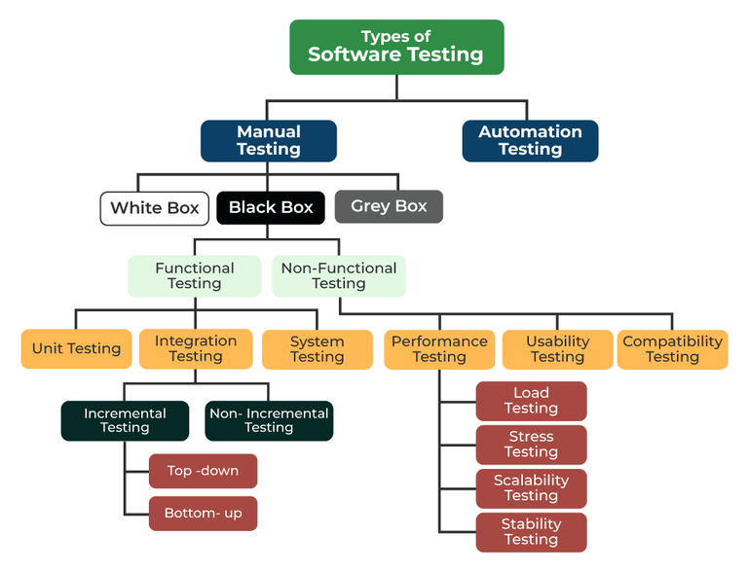

## Introduction to the Normal Distribution

If you ask enough people about their shoe size, you will find that your graphed data is shaped like a bell curve and can be described as normally distributed. (credit: Ömer Ünlϋ)

The normal, a continuous distribution, is the most important of all the distributions. It is widely used and even more widely abused. Its graph is bell-shaped. You see the bell curve in almost all disciplines. Some of these include psychology, business, economics, the sciences, nursing, and, of course, mathematics. Some of your instructors may use the normal distribution to help determine your grade. Most IQ scores are normally distributed. Often real-estate prices fit a normal distribution. The normal distribution is extremely important, but it cannot be applied to everything in the real world.

In this chapter, you will study the normal distribution, the standard normal distribution, and applications associated with them.

The normal distribution has two parameters (two numerical descriptive measures), the mean (μ) and the standard deviation (σ). If X is a quantity to be measured that has a normal distribution with mean (μ) and standard deviation (σ), we designate this by writing

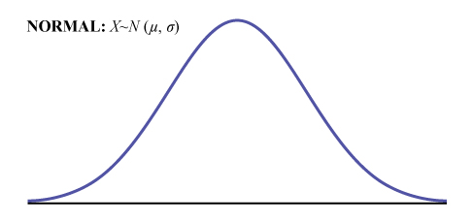

The probability density function is a rather complicated function. **Do not memorize it**. It is not necessary.

f(x)=1σ√2π⋅e−12⋅(x−μσ)2𝑓(𝑥)=1𝜎2𝜋⋅𝑒−12⋅(𝑥−𝜇𝜎)2

The cumulative distribution function is P(X < x). It is calculated either by a calculator or a computer, or it is looked up in a table. Technology has made the tables virtually obsolete. For that reason, as well as the fact that there are various table formats, we are not including table instructions.

The curve is symmetrical about a vertical line drawn through the mean, μ. In theory, the mean is the same as the median, because the graph is symmetric about μ. As the notation indicates, the normal distribution depends only on the mean and the standard deviation. Since the area under the curve must equal one, a change in the standard deviation, σ, causes a change in the shape of the curve; the curve becomes fatter or skinnier depending on σ. A change in μ causes the graph to shift to the left or right. This means there are an infinite number of normal probability distributions. One of special interest is called the **standard normal distribution**. The following video gives an example of data that would fall into a normal distribution.

### EXAMPLE

Your instructor will record the heights of both men and women in your class, separately. Draw histograms of your data. Then draw a smooth curve through each histogram. Is each curve somewhat bell-shaped? Do you think that if you had recorded 200 data values for men and 200 for women that the curves would look bell-shaped? Calculate the mean for each data set. Write the means on the x-axis of the appropriate graph below the peak. Shade the approximate area that represents the probability that one randomly chosen male is taller than 72 inches. Shade the approximate area that represents the probability that one randomly chosen female is shorter than 60 inches. If the total area under each curve is one, does either probability appear to be more than 0.5?

# Formula Review

X ∼ N(μ, σ)

μ = the mean σ = the standard deviation

## Glossary

**Normal Distribution**

a continuous random variable (RV) with pdf f(x)=1σ√2π⋅e−12⋅(x−μσ)2𝑓(𝑥)=1𝜎2𝜋⋅𝑒−12⋅(𝑥−𝜇𝜎)2, where μ is the mean of the distribution and σ is the standard deviation; notation: X ~ N(μ, σ). If μ = 0 and σ = 1, the RV is called the **standard normal distribution**.

**LICENSES AND ATTRIBUTIONS**